DEV APE Server Set-up

Schindler CRD Applications

Exported on 2025-08-19 05:07:31

Table of Contents

**No table of contents entries found.**

**Step 1:  Installation of Creo-View Adapter**

1.1 Select the setup.exe and run as admin

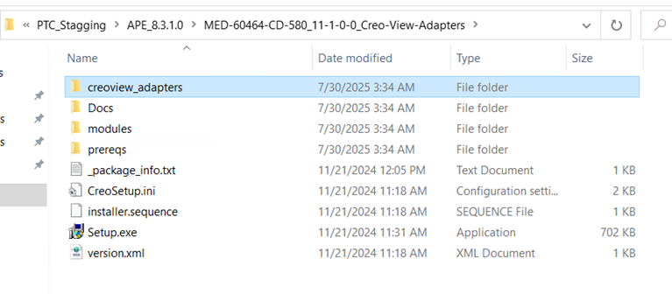

1.2 Select next

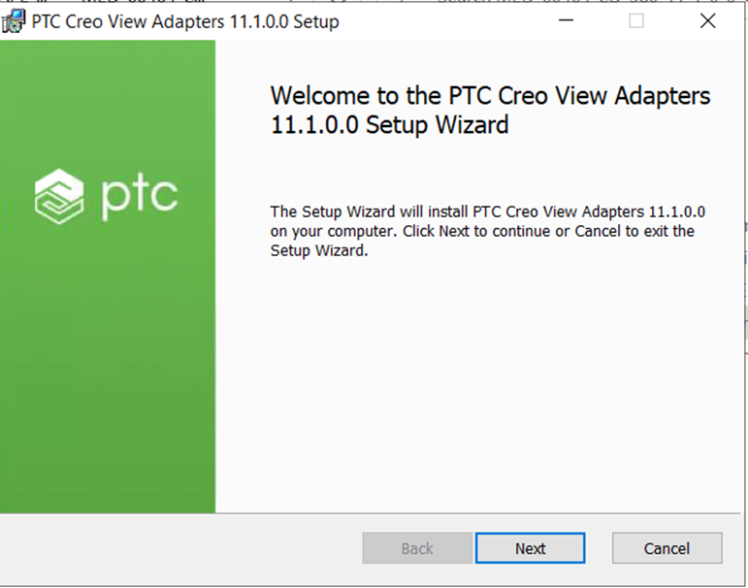

1.3 Accept the License Agreement

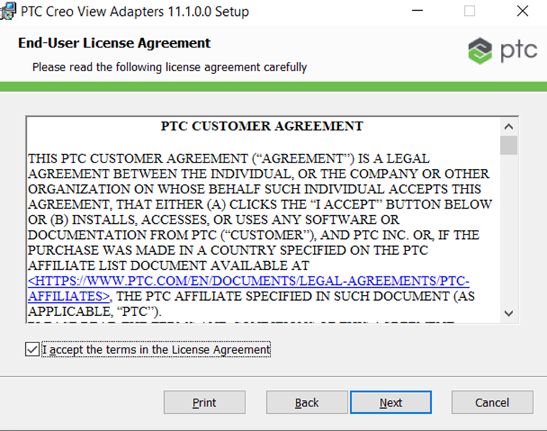

1.4 Select The installation directory as **D:\ptc\creo_view_adapter**

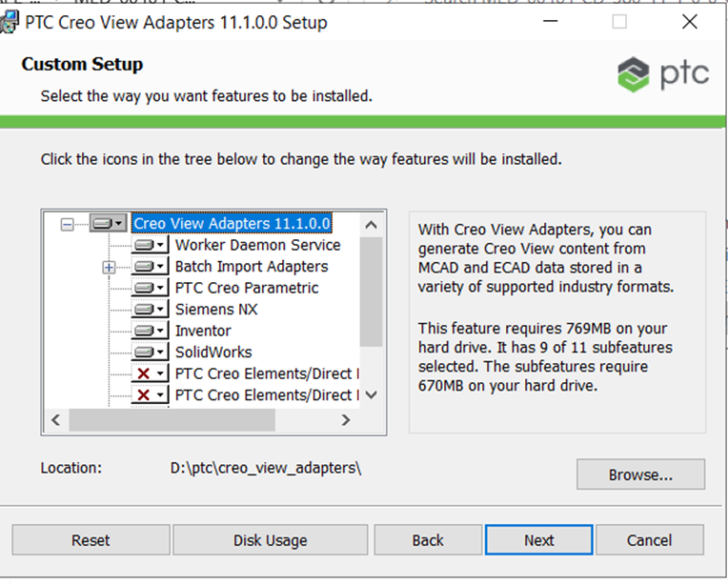

1.5 Select as per below screen shot and Click next

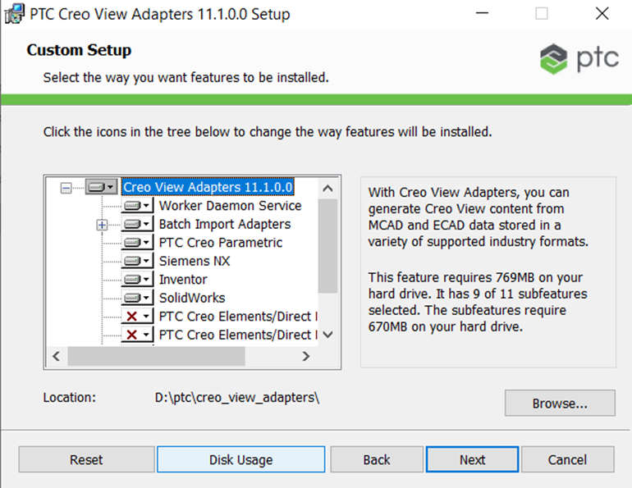

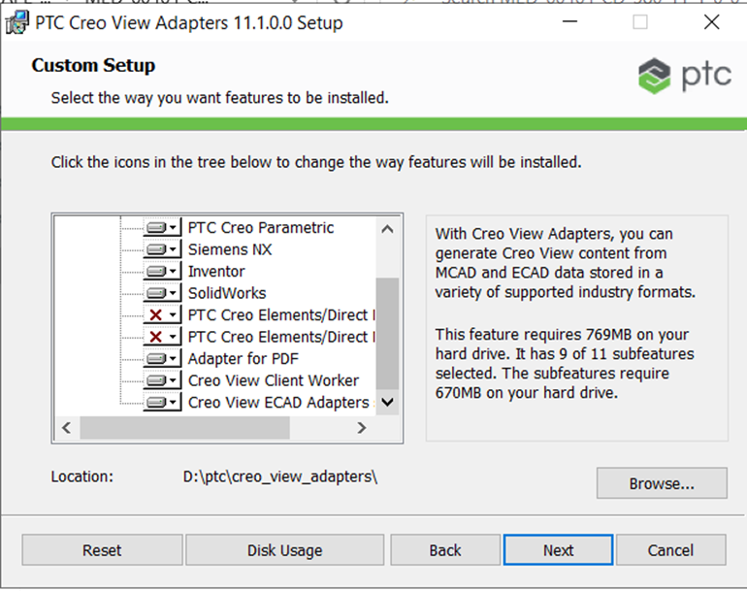

1.6 Set port as 601 and click next

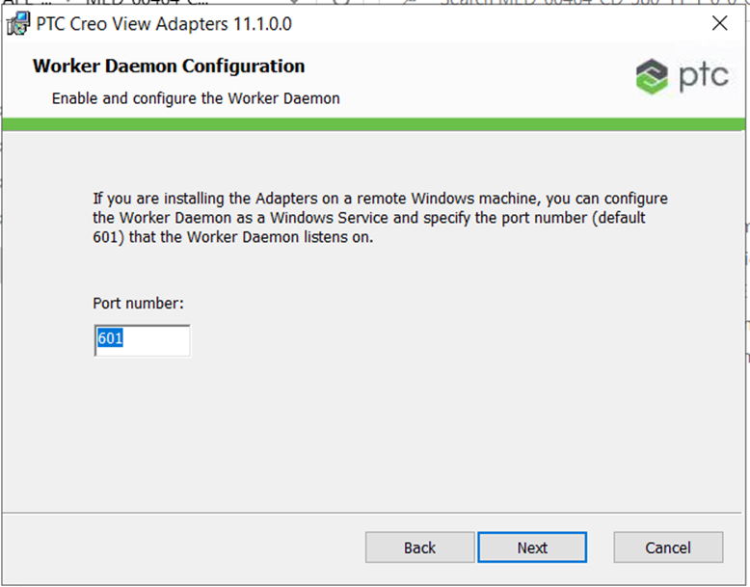

1.7 Click in Install

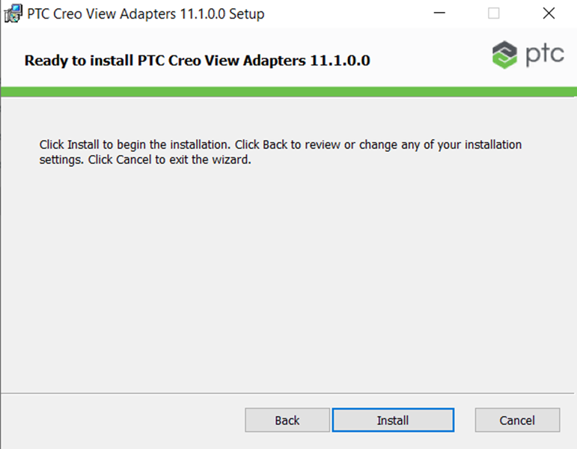

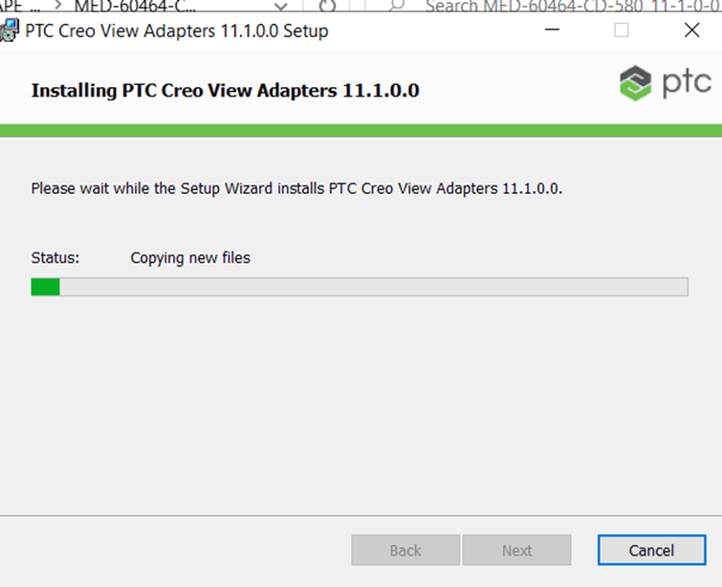

**Step 2 : Amazon corretto installation**

2.1 Run the amazon-corretto-21.0.7.6.1-windows-x64.msi file as an admin

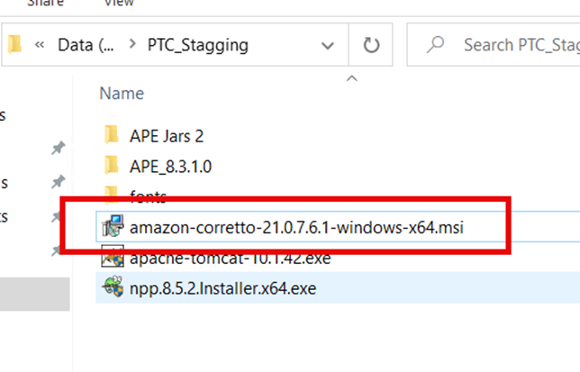

2.2 Select next

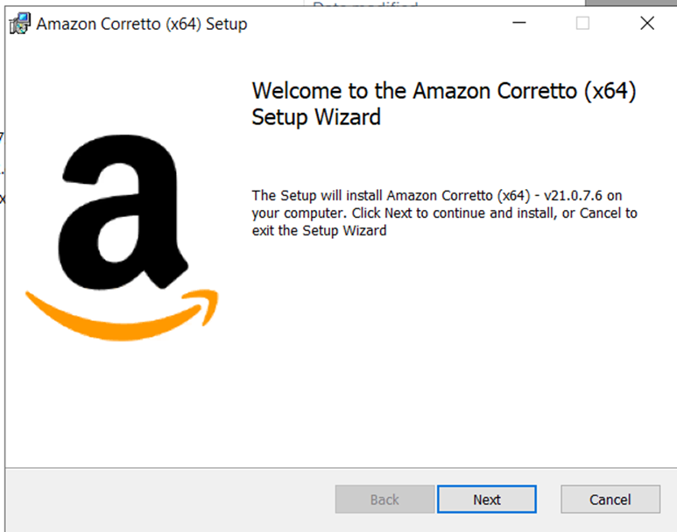

2.3 Select the installation Directory

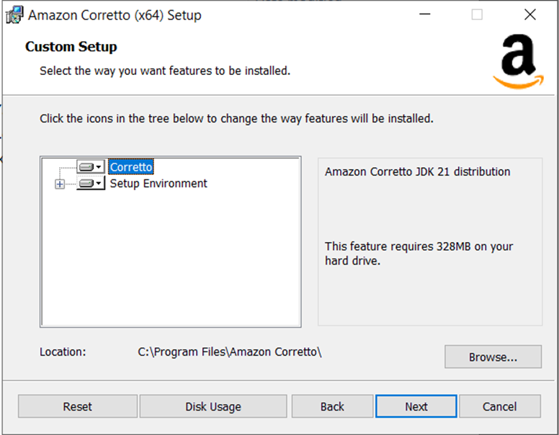

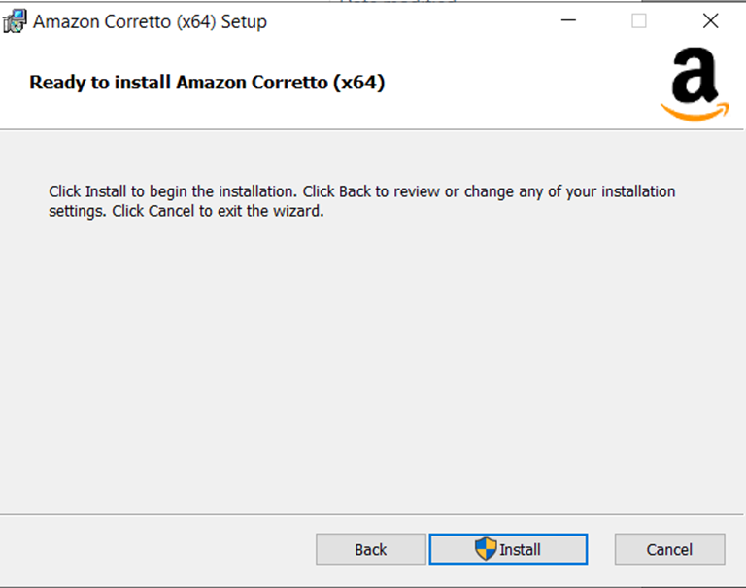

2.4 Click on Finish

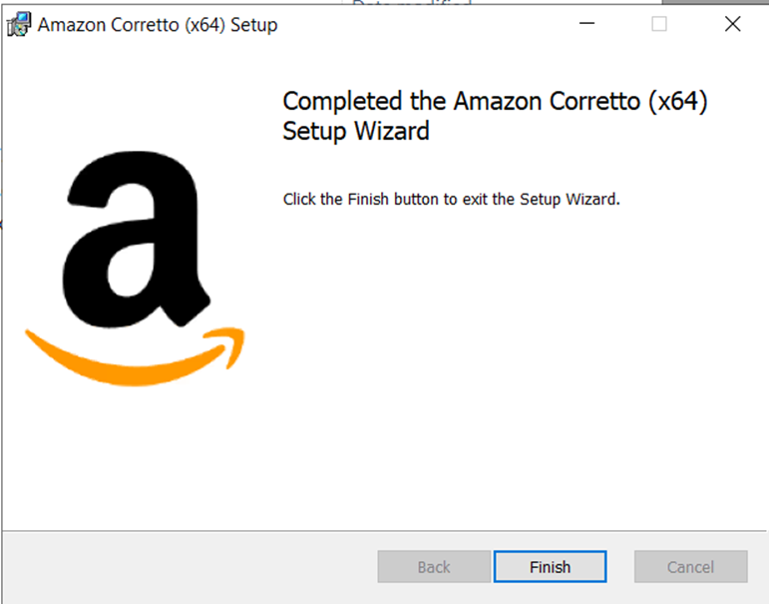

**Step 3: Tomcat installation**

3.1 Select apache-tomcat-10.1.42.exe and run as admin

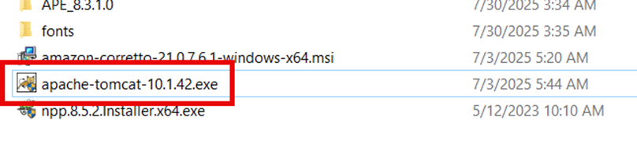

3.2 Click on next

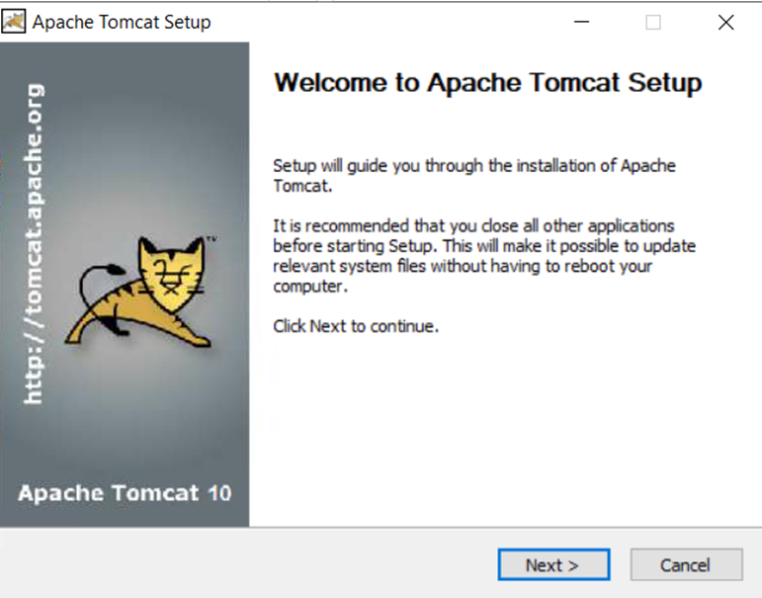

3.3 Accept the License agreement

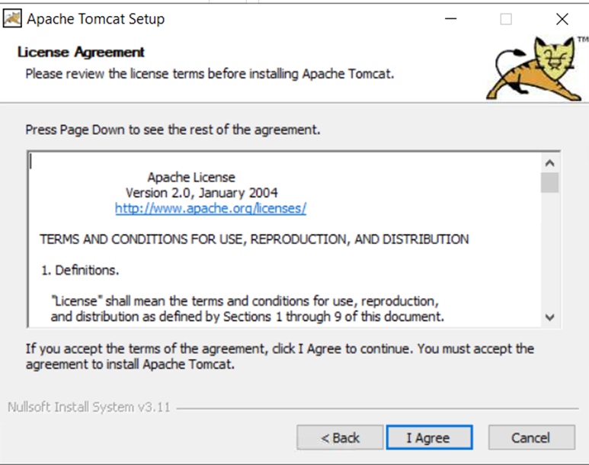

3.4 Select the option as shown in the below screen shot

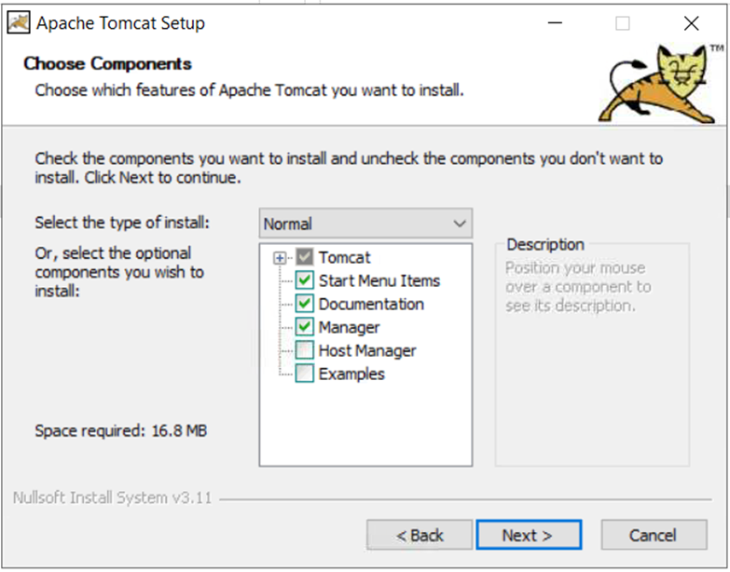

3.5 Define all the values as per below screen shot

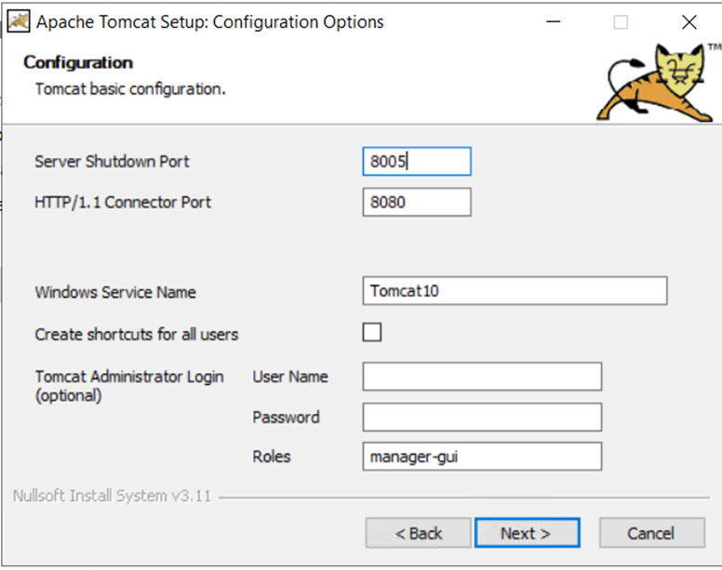

3.6 Provide Amazon Corretto installation directory and click next

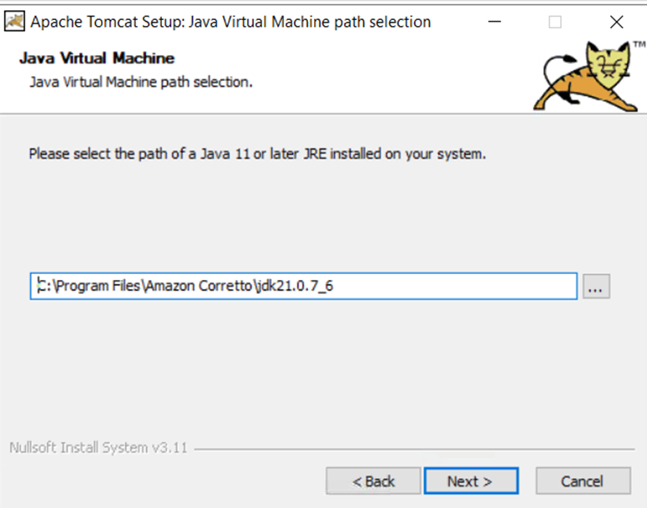

3.7 Define installation directory for tomcat

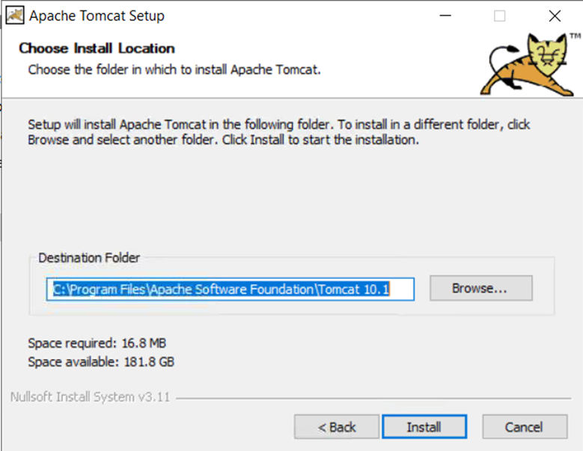

3.8 Click on Finish

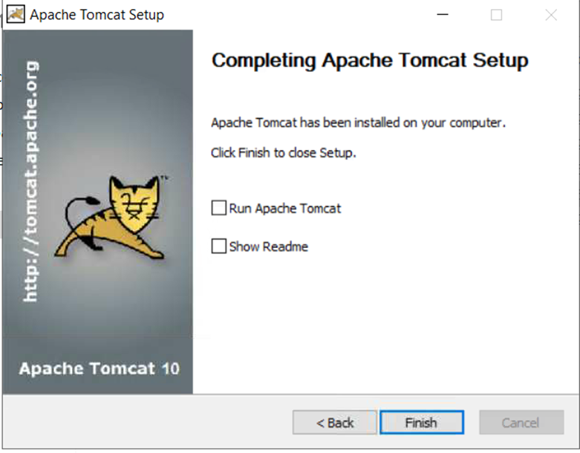

**Step 4: Installation of Arbortext Publish engine**

4.1 Run **ArbortextPE.msi** from installable folder

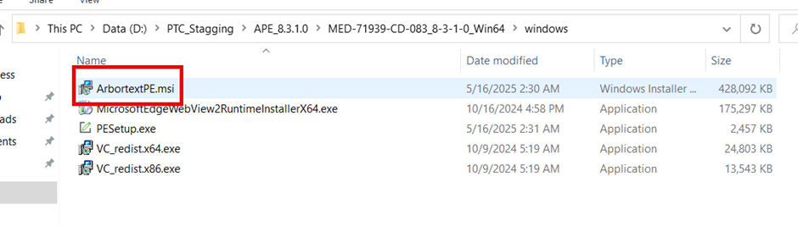

4.2 Click next

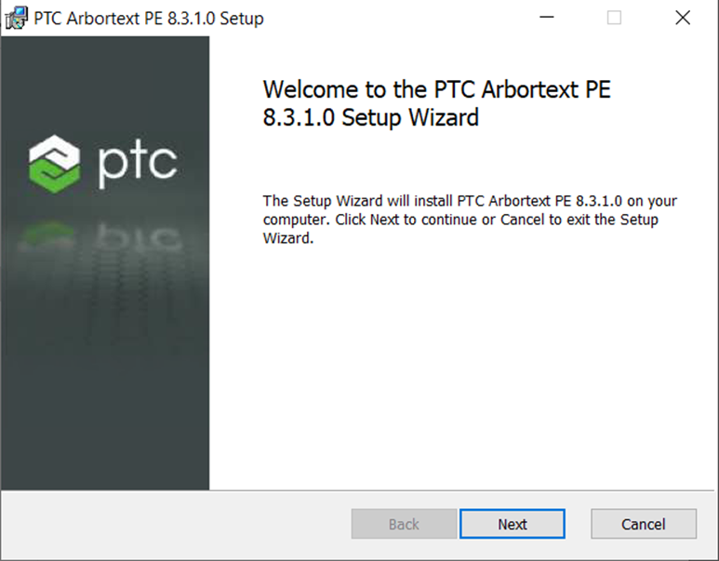

4.3 Accept License agreement

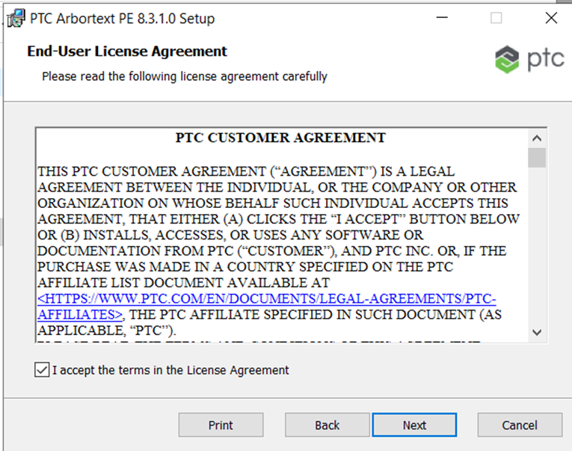

4.4 Define installation directory ArbortextPE

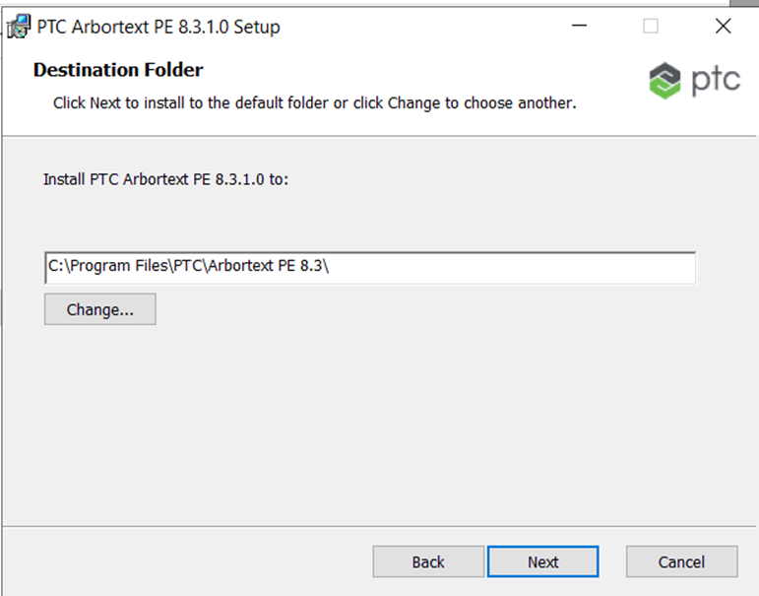

4.5 Click install

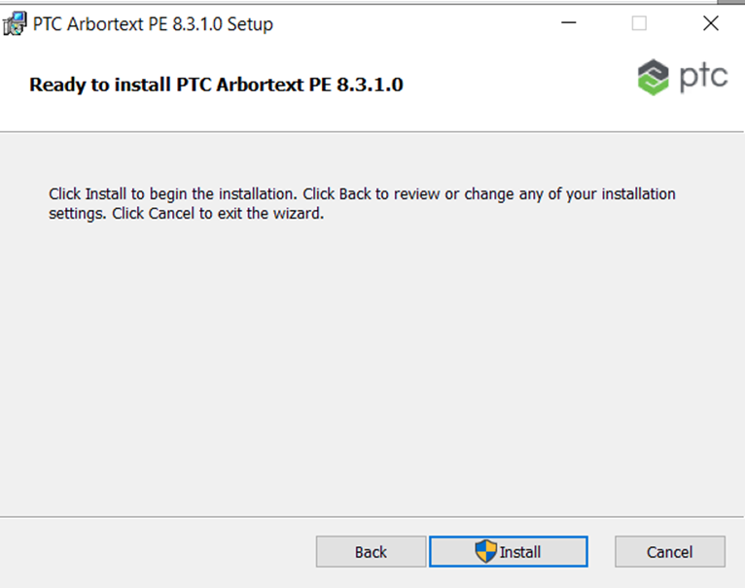

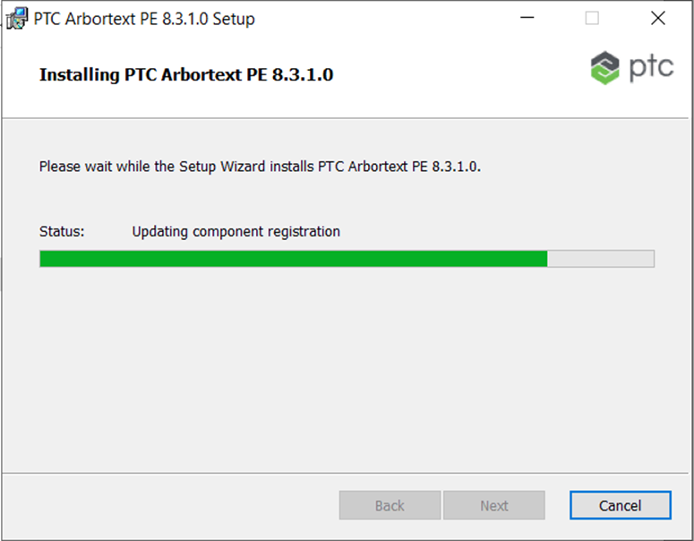

4.6 Click Finish

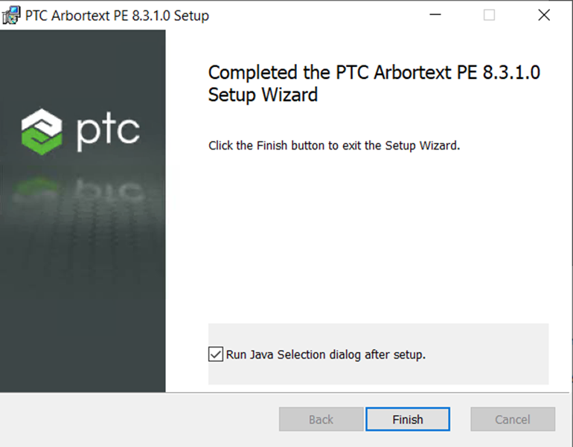

4.7 Select the Amazon corretto from the window and click OK

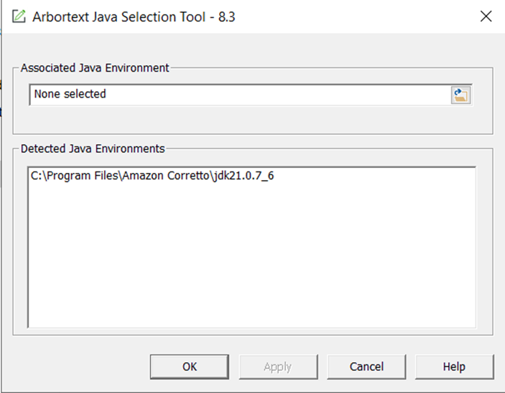

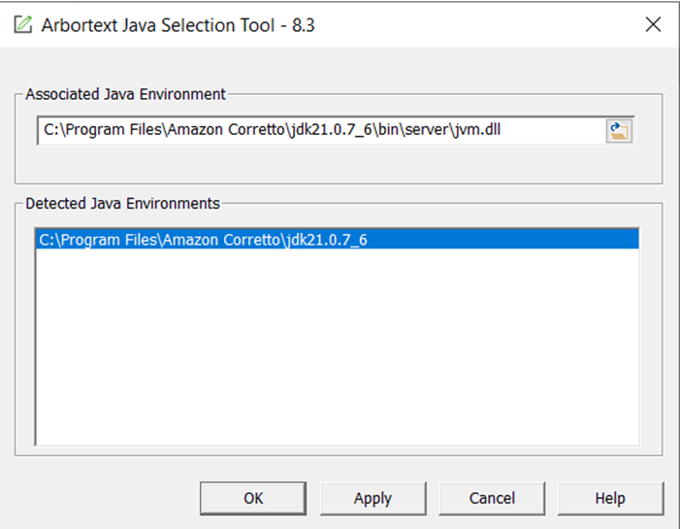

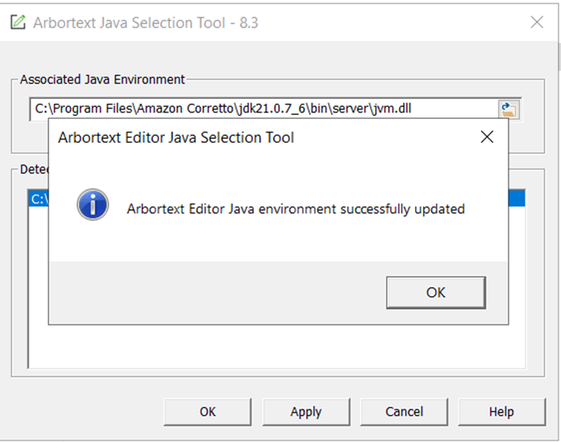

4.8 Click on yes to register the correct PE subprocess COM server

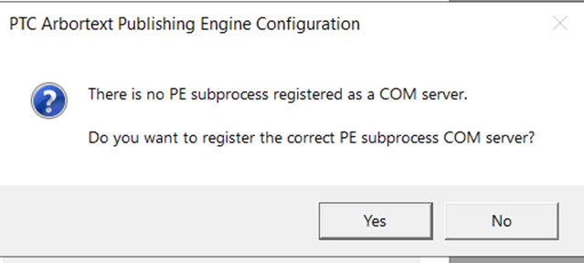

4.9 It will Ask to integrate ArbortextPE with tomcat so select yes

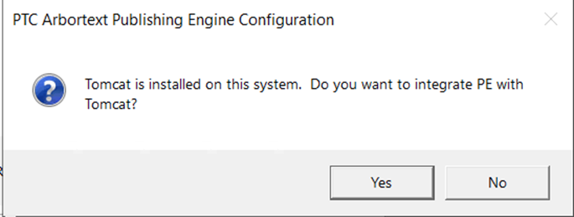

4.10 Click OK

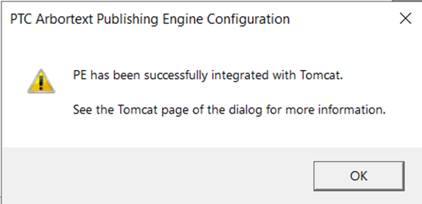

4.11 To check the integration open **PTC Arbortext Publishing Engine Configuration 8.3**

Please check the Deployment Descriptor path "**C:\Program Files\PTC\Arbortext PE\e3\e3\WEB-INF\web.xml"**

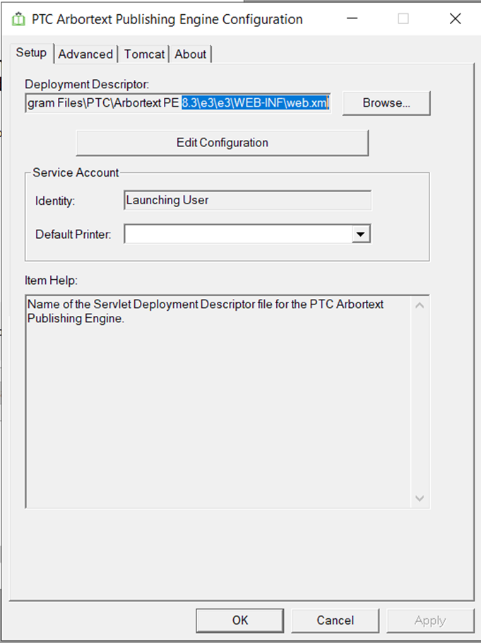

4.12 Go to Tomcat tab and check the installation path of tomcat is showing or not **"C:\Program Files\Apache Software Foundation\Tomcat 8.5"**

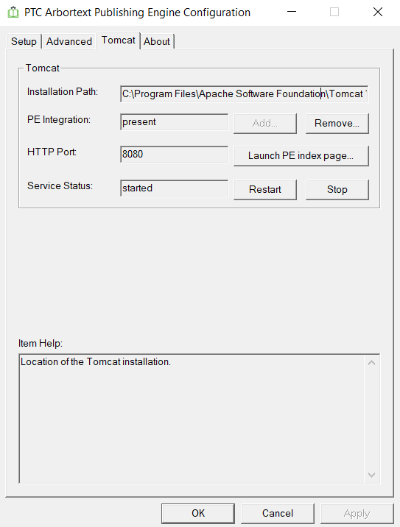

4.13 Now click on start

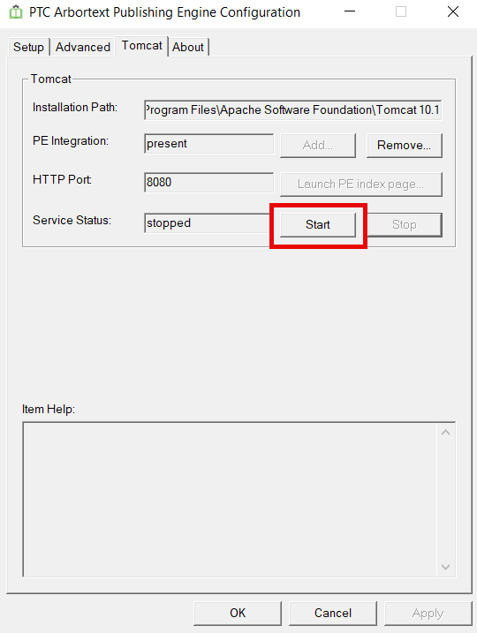

4.14 Once started click on **“Launch PE index page”**

